**Project Design Phase-I**

**Solution Architecture**

|  |  |
| --- | --- |
| Date | 19 September 2023 |
| Team ID | **593090** |
| Project Name | |  | | --- | | TrafficTelligence: Advanced Traffic  Volume Estimation with Machine Learning | |  | |
| Maximum Marks | 4 Marks |

**Solution Architecture:**

A Solution Architecture template is a structured document that outlines the high-level structure and design of a proposed solution to address a particular problem or meet specific requirements. It serves as a blueprint for the development and implementation of a system or application.

Find the best tech solution to solve existing business problems

* Briefly describe the project's goals and objectives.
* Clearly define the boundaries and limitations of the project.
* List and detail the specific functionalities required.
* Specify performance, security, scalability, and other non-functional requirements.
* Outline the guiding principles for the solution architecture.
* Specify any design patterns to be used in the solution
* Provide an overview of the overall system architecture.
* List and specify the technologies and tools for the user interface.
* Identify the database management system and related tools.
* Detail how the solution will interact with external systems.
* Define the APIs used for internal and external communication.
* Provide a detailed data model with entity-relationship diagrams.
* Describe the mechanisms for user authentication and authorization.
* Detail how system performance and health will be monitored.
* Outline how the system will scale to handle increased loads.
* List any external services, libraries, or components the solution depends on.
* Document potential risks and propose mitigation strategies.
* Provide an estimate of the costs associated with designing and implementing the advanced traffic volume estimation solution.
* Include documentation on the chosen machine learning algorithms, model training processes, and performance metrics.
* Present any visual mock-ups or prototypes for the user interface or data visualization.

**Example - Solution Architecture Diagram:**

**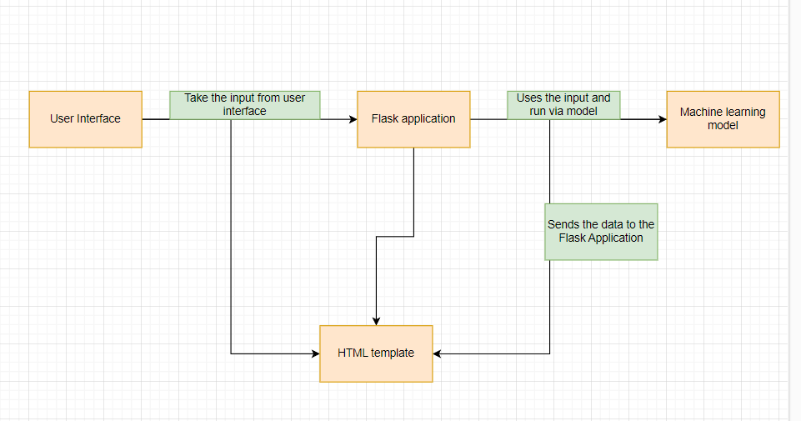***Figure 1: Architecture and data flow of the voice patient diary sample application*

**Reference: https://aws.amazon.com/blogs/industries/voice-applications-in-clinical-research powered-by-ai-on-aws-part-1-architecture-and-design-considerations/**